C programs second week

Day-1 8 to 9

1 program -reverse integer

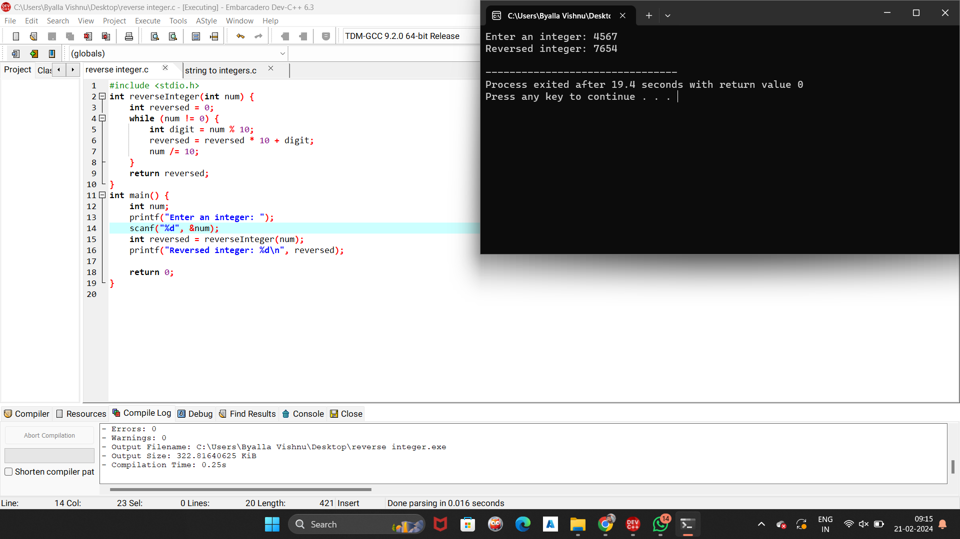

2 program

String to integers

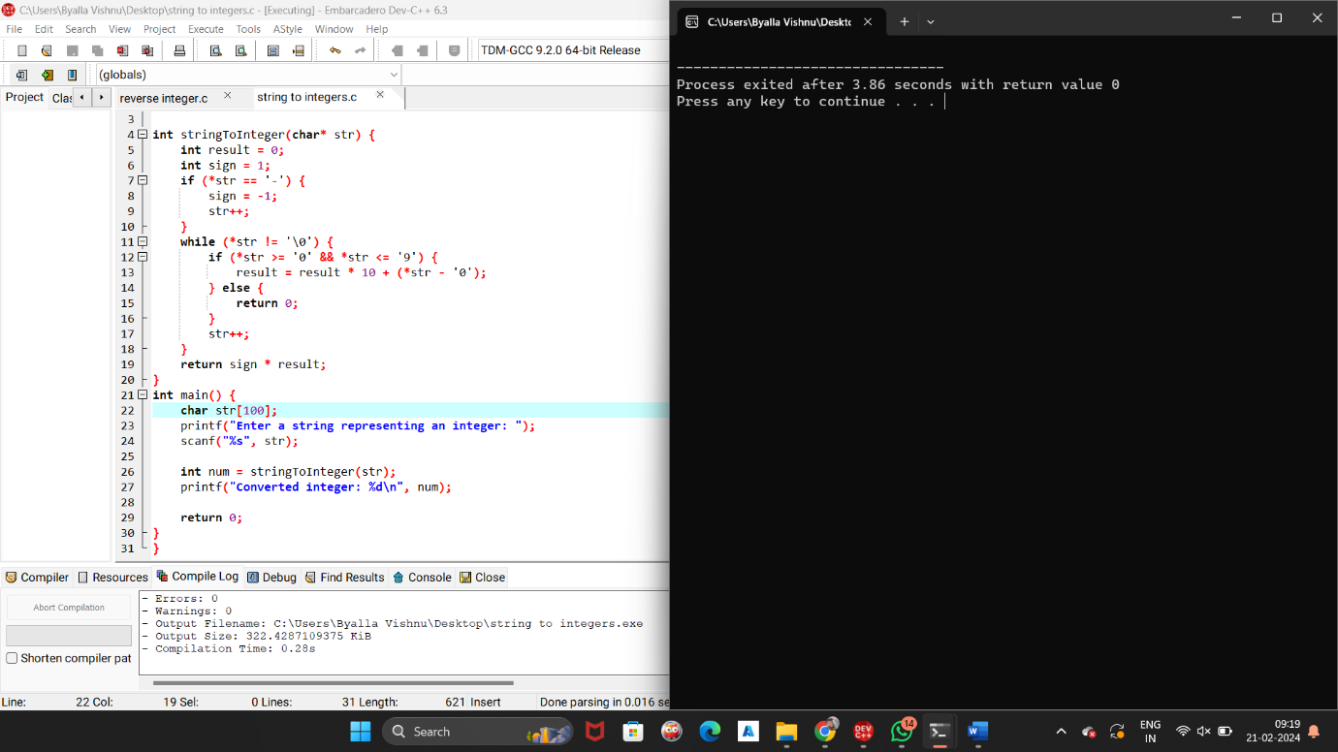

9 - 10

Program 3

Integer to roman

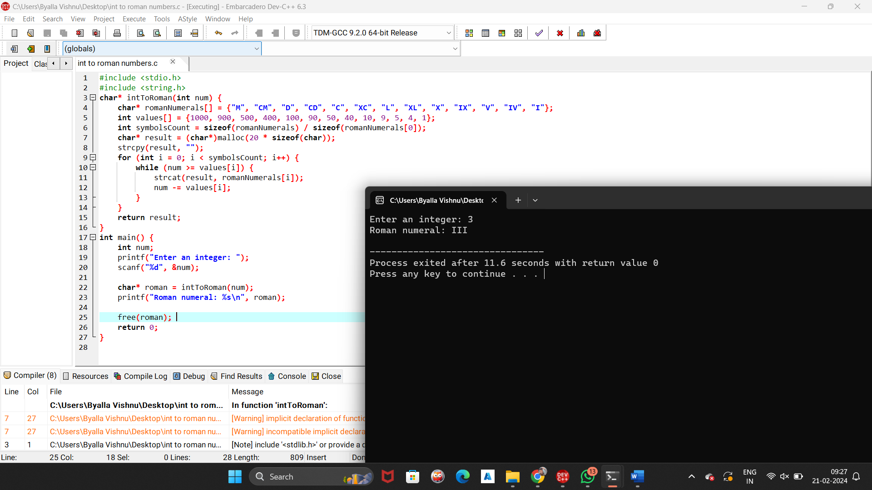

4- problem

Divide two numbers

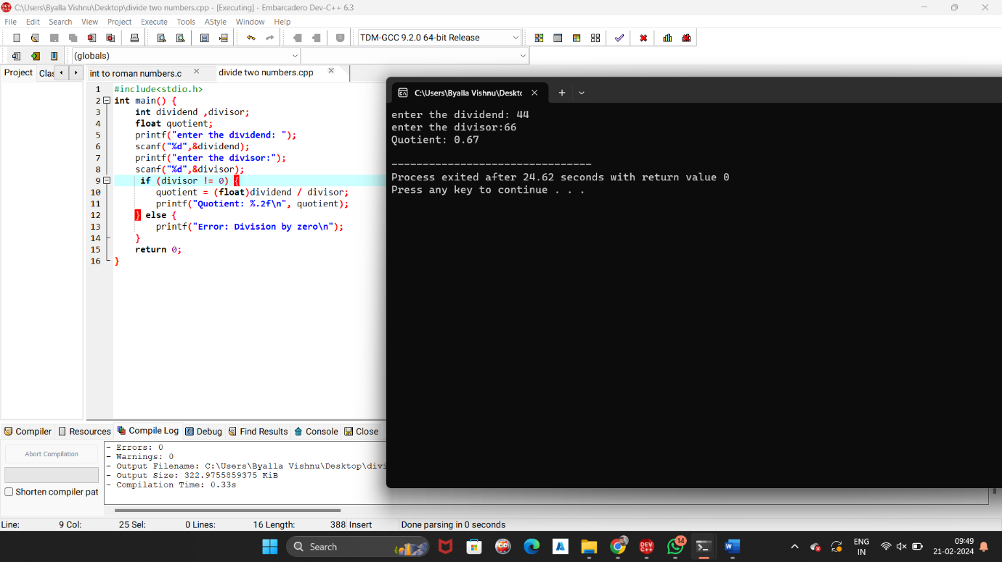

5- problem

Smallest missing positive integer in an array of integers

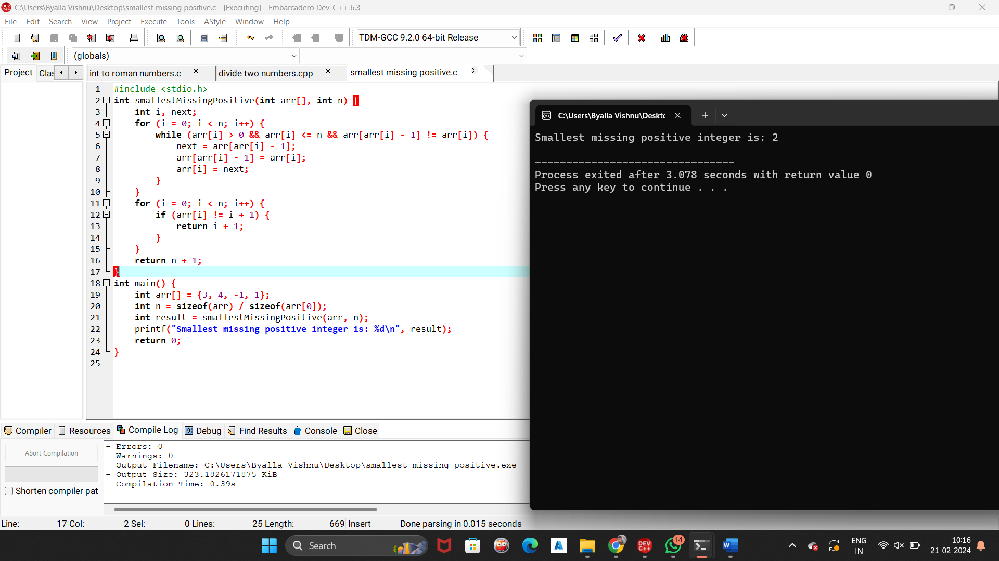

10 -11

6 program

longest increasing subarray.

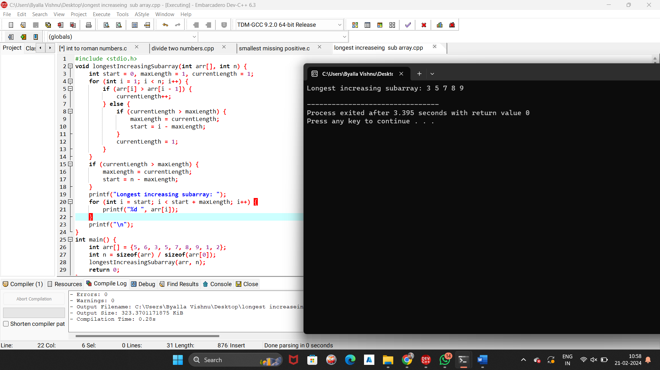

7 program

subarray with the largest sum.

